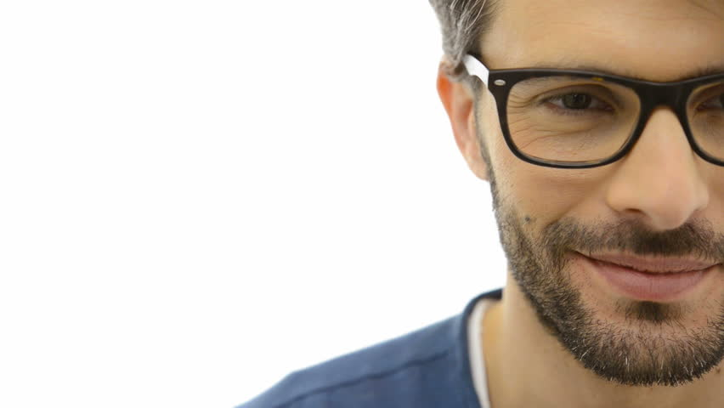

Gynaecomastia surgery & liposuction
for John Doe
Date: dd/mm/yyyy
Valid until: dd/mm/yyyy

Proposal to Name Surname
It is our explicit guarantee that your treatment will be carried out by world-class professionals and at the highest standard.
Furthermore, our honest pricing is fair to every patient. This is because you will mostly pay for your treatment rather than, for example, expensive clinic’s location in the centre of London.

Treatment: liposuction (inner & outer thighs, knees)
The surgeon recommends the following treatment – liposuction of inner and outer thighs.
Exact price for the proposed treatment plan: €3625 / £2890 at the current exchange rate. A season discount of €XXX is already applied.

Your surgeon
Treatment will be performed by Dr. Domantas Stundys. You can find more information about him and his previous experience here: http://wellness-travels.com/plastic-surgeon-domantas-stundys/

What is included
The price includes everything connected with the treatment: surgery, hospitalisation, blood tests, needed consultations, special garments, necessary anaesthesia, administration. It also includes:
- help finding best airplane ticket deals & discount for accommodation booking
- meeting & drop-off at Kaunas (KUN) airport*, as well as personal driver within Lithuania
- phone + Lithuanian SIM for unlimited calls; including 24/7 assistance
- help with after-care & insurance of up to € 35,000 against injury resulting from malpractice

Travel & accommodation costs
Recommended Accommodation: Kaunas City Hotel. Discounted Wellness Travels price – single room €28/night; double: €35/night. Or, if you prefer home living – our special apartment in Kaunas Old Town.
Recommended Air-travel: please ask our assistant for help. We would be glad to find you the most convenient and cheapest flight tickets to and from Lithuania.
*If your flight is not to Kaunas Airport (KUN), there will be an extra charge of €23 for transportation.

FEEL &
LOOK GREAT.

THANK YOU FOR CHOOSING US | LET’S CONNECT ON:
Facebook | Instagram | YouTube

